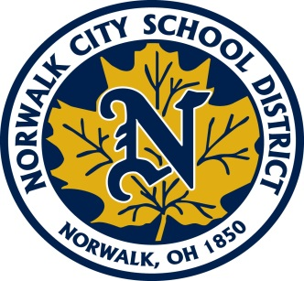
2022-2023

Dear Parent(s) or Guardian(s),

All kindergarten through sixth grade students are a part of a school-wide Title I Program. Title I services are provided to support our students’ progress and achievement in the areas of Reading and Math. During the course of the school year, your child may be provided assistance with various skills. This could be for extra support, assistance or enrichment.

This year, for our Title I Program, we will be working with individual/small group instruction several days per week and whole class instruction and co-teaching. We will be targeting students based primarily on iReady assessments, teacher recommendations and AIR Assessment scores. Our goal is to assist as many students as possible and increase academic growth. This assistance will be provided during the regular school day.

Your signature acknowledges that you are aware of the program and the services provided. Please sign and return this form as quickly as possible.

We will be available to meet with you to discuss your child’s needs and progress, if you call the school and arrange a conference. We are looking forward to working with your child this year. If you have any questions please call. Thank you for your cooperation.

Sincerely,

Title I Program Teacher

Mr. Luke McCoy Main Street School 419-660-1957
Licensure: Middle Childhood Language Arts & Reading/Social Studies (Grades 4-9)

Please return this paper to your child’s teacher as soon as possible.

_______________________________ __________________________________
(Student Name- Please Print) (Parent Signature)

